**1**

**Template**

## Define your problem statement

**Before you collaborate**

A little bit of preparation goes a long way with this session. Here’s what you need to do to get going.

**10 minutes**

### What problem are you trying to solve? Frame your problem as a How Might We statement. This will be the focus of your brainstorm.

**5 minutes**

**2**

## Brainstorm

### Write down any ideas that come to mind that address your problem statement.

**10 minutes**

**3**

## Group ideas

**TIP**

You can select a sticky note and hit the pencil [switch to sketch] icon to start drawing!

### Take turns sharing your ideas while clustering similar or related notes as you go. Once all sticky notes have been grouped, give each cluster a sentence-like label. If a cluster is bigger than six sticky notes, try and see if you and break it up into smaller sub-groups.

**20 minutes**

**4**

## Prioritize

### Your team should all be on the same page about what's important moving forward. Place your ideas on this grid to determine which ideas are important and which are feasible.

**20 minutes**

## After you collaborate

### You can export the mural as an image or pdf to share with members of your company who might find it helpful.

#### Vijayan S

**A Team gathering**

Define who should participate in the session and send an invite. Share relevant information or pre-work ahead.

**Brainstorm**

**& idea prioritization**

Use this template in your own brainstorming sessions so your team can unleash their imagination and start shaping concepts even if you're not sitting in the same room.

**PROBLEM**

**How might we [your problem statement]?**

**sathya seelan E**

**Quick add-ons**

#### Share the mural

**TIP**

Add customizable tags to sticky notes to make it easier to find, browse, organize, and categorize important ideas as themes within your mural.

Students can register and login into the system once their registration is approved by the admin.

The admission should be like cut off in higher secondary studies.

with the help of previous year data set we can predict

It also contains the university information and ratings

**Share a view link** to the mural with stakeholders to keep them in the loop about the outcomes of the session.

Students can register and login into the system once their registration is approved by the admin.

The student will enter his/her profile details using the user interface

#### Export the mural

**B Set the goal**

Think about the problem you'll be focusing on solving in the brainstorming session.

With the help of their profile we are going to predict their admission

With the help of their profile we are going to predict their admission

use random forest to predict the probability of being accepted into graduate programs.

Export a copy of the mural as a PNG or PDF to attach to emails, include in slides, or save in your drive.

we can use algorithms it will decrease our work

The admission prediction is based on their performance.

If some student not study higher secondary but they completed diplamo then their diplamo mark also consider.

The prediction is based on their SSLC and Higher Secondary mark

**Keep moving forward**

**C Learn how to use the facilitation tools**

Use the Facilitation Superpowers to run a happy and productive session.

[**Open article**](https://support.mural.co/en/articles/2113740-facilitation-superpowers)

When students come from rural places , they find it hard

to go along with the formal procedures. So, this

application helps them a lot and eases out their fear

Cumulative Grade Point Average(CGPA) to evaluate the student's competence.

**10 minutes** to prepare

**1 hour** to collaborate

**2-8 people** recommended

**Key rules of brainstorming**

To run an smooth and productive session

. This

helps the student not only to help in filling out the application

forms but also give the students an idea about their future

college by calculating their cut off.

**Vishal Kumar S**

The predicted output gives them a far idea about their chances for a particular university.

**Sheshanth Kumar M**

# 

Having a good score in international test like GRE,TOEFL enhance the chance of getting admitted.

Students aspiring to pursue higher studies are in a perennial state of confusion when it comes to deciding their university

The main principle behind the need of

college admission system is easy supervision of institutes. It

can handle the details of students such as fee details or marks

details.

The student will enter his/her profile details using the user interface

#### Strategy blueprint

Define the components of a new idea or strategy.

Transforming the target data and removing some outliers provide an amazing improvement in the model performance.

university ratings

#### [Open the template](https://app.mural.co/template/e95f612a-f72a-4772-bc48-545aaa04e0c9/984865a6-0a96-4472-a48d-47639307b3ca)

**Customer experience journey map**

Understand customer needs, motivations, and

Transforming the target data and removing some outliers provide an amazing improvement in the model performance.

Cumulative Grade Point Average(CGPA) to evaluate the student's competence.

Stay in topic.

Defer judgment.

Encourage wild ideas.

Listen to others.

**Importance**

The CGPA is the most important score to get admitted

If each of these tasks could get

Whatever may be their scores , this

application helps to

find the best colleges . Hence, our proposed computer

aided system will help the students to get the list of all

colleges in which they could get the admission at the click of a button

university ratings

Transforming the target data and removing some outliers provide an amazing improvement in the model performance.

With the help of their profile we are going to predict their admission

The student will enter his/her profile details using the user interface

obstacles for an experience.

[**Open the template**](https://app.mural.co/template/b7114010-3a67-4d63-a51d-6f2cedc9633f/c1b465ab-57af-4624-8faf-ebb312edc0eb)

Cumulative Grade Point Average(CGPA) to evaluate the student's competence.

**Strengths, weaknesses, opportunities & threats**

Go for volume. If possible, be visual.

When students come from rural places , they find it hard

to go along with the formal procedures. So, this

application helps them a lot and eases out their fear

done without any difficulty or cost, which would have the most positive impact?

Identify strengths, weaknesses, opportunities, and threats (SWOT) to develop a plan.

#### [Open the template](https://app.mural.co/template/6a062671-89ee-4b76-9409-2603d8b098be/ca270343-1d54-4952-9d8c-fbc303ffd0f2)

##### TIP

Students can register and login into the system once their registration is approved by the admin.

which is useful for the students who want to join in college for higher studies

We are going to make a university eligibility admit predictor

Participants can use their cursors to point at where sticky notes should go on the grid. The facilitator can confirm the spot by using the laser pointer holding the **H key** on the keyboard.

[**Share template feedback**](https://muralco.typeform.com/to/CiqaHVat?typeform-source=app.mural.co)

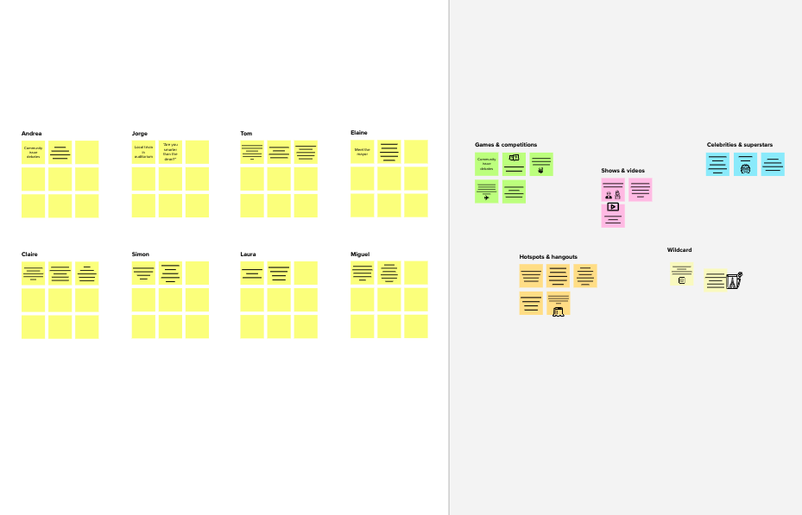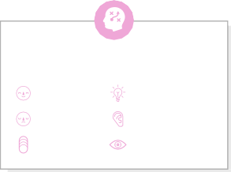

# 

The aim of this project is to help students in shortlisting universities with their profiles.

The predicted output gives them a fair idea about their admission chances in a particular university.

**Feasibility**

[**Share template feedback**](https://muralco.typeform.com/to/CiqaHVat?typeform-source=app.mural.co)

Regardless of their importance, which tasks are more feasible than others? (Cost, time, effort, complexity, etc.)

**Need some inspiration?**

See a finished version of this template to kickstart your work.

[**Open example**](https://app.mural.co/template/e5a93b7b-49f2-48c9-afd7-a635d860eba6/93f1b98d-b2d2-4695-8e85-7e9c0d2fd9b9)